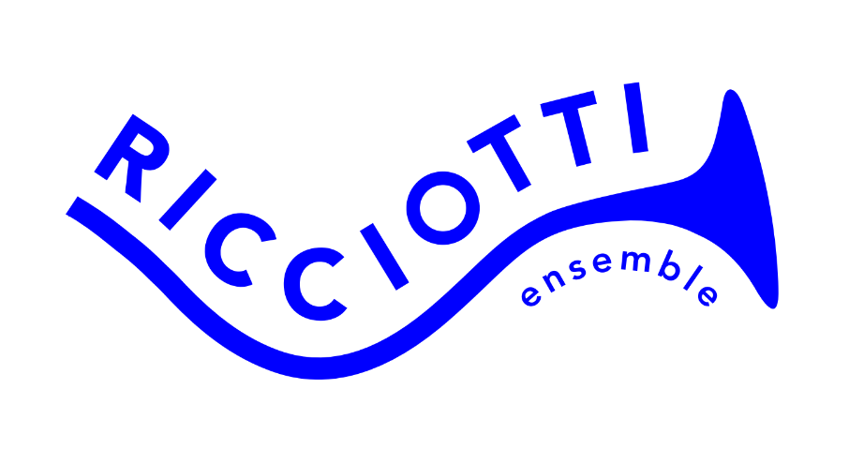
REGISTRATION FORM (English)
RICCIOTTI'S GRAND ARRANGING COMPETITION 2026
Name:
Age:
Education/Profession:
Street name and number:
Zip code:
Place of residence:
Email address:
Phone number:
Title arrangement:
Title original musical piece(s):
Your application is valid if you send the following three documents no later than Tuesday 8 September 2026:
- This registration form
- An anonymized PDF version of the score (transposed) (A4, portrait)
- Mp3 demo of the score
The Ricciotti ensemble consists of 43 musicians:
2 flutes (1 of which is possibly piccolo)
2 oboes
2 clarinets (in B flat)
2 alto saxophones (in E flat)
2 bassoons
2 horns (in F)
2 trumpets (in B flat)
1 trombone
2 percussionists (including 1 drummer and 1 classical percussionist)
8 1st violins
6 2nd violins
5 violas
4 cellos
3 double basses (1 of which is possibly amplified double bass or bass guitar)
Duration of the arrangement is a minimum of 3, a maximum of 5 minutes.
If your arrangement is chosen for the final, you are expected to provide the parts yourself.
These must be submitted before the 23rd of September.
The final and ceremony will take place on Sunday evening the 18th of October in ‘het Verhalenhuis’ in Haarlem.
Save the date!
Mail this registration form and your arrangement in PDF and MP3 no later than Tuesday 8 September 2026 to: info@ricciotti.nl

